Workplace Edge – Lesson 18
Legend- Orange- 360 Content Pink- Facilitator Notes Purple- Synthesia Video (if applicable)-- ** added content** Italicizes

1. Lesson Overview
Lesson Title: Everyday Interruptions
Pathway (I, We, Us): We
Skill Focus: Confidence Building, Interruption Recovery
Workplace Challenge: “When I’m interrupted or the plan changes, I lose my words.”
(* synthesia video 1- 360 content * Welcome to Everyday Interruptions.Individual videos - Google Drive
Interruptions are a part of daily life—whether in meetings, conversations, or even while you’re focusing on a task. Sometimes they feel small, and other times they can throw you completely off track.
*Synthesia ONLY* In this lesson, you’ll learn how to identify different types of interruptions, perceive your own emotional state when they happen, and recover using neutral yet assertive phrases. By practicing these skills, you’ll be better prepared to handle interruptions calmly and effectively.*)

2. Learning Objectives 360 content - list
Learners will be able to:
- Identify types of interruptions
- Perceive their own emotional state when being interrupted
- Recover from being interrupted using neutral yet assertive phrases

3. Spark (5–10 minutes) 360 content/ synthesia video 2 Individual videos - Google Drive
The emotional relevance here is to become more aware of how we feel when interrupted, and to objectively decide to respond professionally (i.e., calmly and logically) rather than to let our feelings or pressures (e.g., deadlines) dictate an emotional reaction. This leads to practical relevance: Navigating through conversations where interruptions are likely to occur while at the same time, considering why interruptions happen in business contexts (interpersonal tensions, tight deadlines, guard railing colleagues who may be off track, etc.).
- Reflection Activity: downloadable for video 4, 5
Me_Lesson_18_Spark_Activity_Nori_Everyday_Interruptions_2025_07_29 *Everyday Interruptions, Spark Activity 1 and 2* found here Course Content assignments - Google Drive and Course Content assignments - Google Drive
Learners will be able to link lived experience to common types of interruptions and possible reactions and responses. See 6. Facilitator Notes (Required), below. Shawna and Courtney, please embed this table in an interactive way in the LMS so learners can track their understanding. There is no key for this exercise.
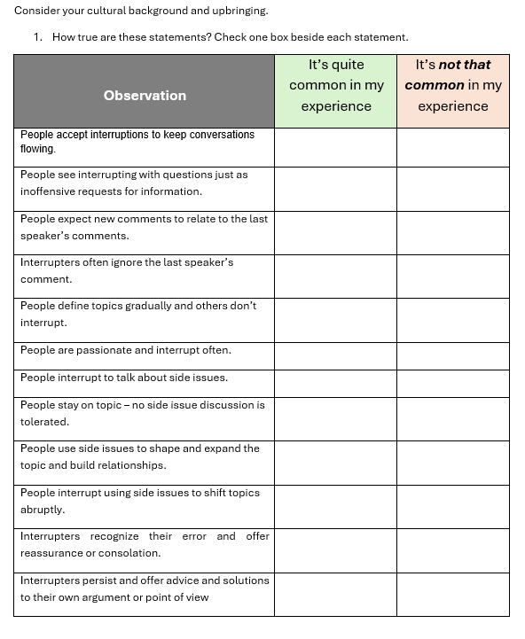

4. Shift (20–25 minutes)
Input 1 (text/audio/video title and summary): Audio Script Please incorporate this script using AI animation in the LMS so learners may see a parallel with their own work experiences.
Transcript/Link/File: Me_Lesson_18_Shift_The_Scheduling_Dilemma_Audioscript_for_Input_Nori_Everyday_Interruptions_2025_07_29 (*Everyday Interruptions, Audio script The Scheduling Dilemma*)
Answer Key or Discussion Guide: Me_Lesson_18_Shift_The_Scheduling_Dilemma_Audioscript_with_Options_Nori_Everyday_Interruptions_2025_07_29 (*Everyday Interruptions, Audio script The Scheduling Dilemma- ANSWER KEY*) found here Everyday Interruptions, Activity ANSWER KEY The Scheduling Dilemma.docx - Google Docs (this activity can be added as a sorting activity, 2 piles for appropriate and inappropriate with the highlighted selected to be sorted. Green is correct, red is incorrect)
Input 2 (text/audio/video title and summary): Text . Please embed these expressions in a Drag and Drop format in an interactive way in the LMS to quiz learners, e.g., Headings are on the left side of the screen and jumbled expressions on the right. Then please provide feedback by providing the correct answers to allow for progress tracking. Glossary terms are highlighted. *Everyday Interruptions Glossary Terms (360 interaction, sorting: 5 stacks with bolded title of each section, add all 25 options and learners must drop each option into correct pile (from the 5 bolded titles)* found here glossary true/false quiz.docx - Google Docs
Transcript/Link/File: Me_Lesson_18_Shift_Drag_n_Drop_Activity_Nori_Everyday_Interruptions_2025_07_29 (*Everyday interruptions, Drag and drop activity/answer key (SHIFT)*) found here Everyday interruptions, Drag and drop activity/answey key (SHIFT).docx - Google Docs (this activity would be best suited as another sorting with the 5 categories as the piles and the 25 sentences jumbled OR can be a knowledge check where students choose the correct category for the sentence)
360 Language Focus: Diplomatic phrases to maintain learner’s own momentum and task completion. These phrases are contrasted with less formal, perhaps inappropriate expressions.
360 Guided Practice Task: The purpose is to have learners increase their awareness of Emotional Intelligence quadrants (self-awareness, self-management, social awareness, and relationship management) without explicitly teaching them.
Answer Key or Discussion Guide: Me_Lesson_18_Shift_Drag_n_Drop_Activity_Nori_Everyday_Interruptions_2025_07_29
(*Everyday interruptions, Drag and drop activity/answer key (SHIFT)*) same document as above Everyday interruptions, Drag and drop activity/answey key (SHIFT).docx - Google Docs)

5. Stretch (20 minutes)
Application Tasks:
360 content Learners will read and reflect on interruptible scenarios and check one box reflecting their culture and/or write their opinions and responses about each scenario.
Downloadable Tool: Me_Lesson_18_Stretch_Nori_Everyday_Interruptions_2025_07_29 (*Everyday Interruptions, Stretch Activity 1a here Course Content assignments - Google Drive / 2a here Course Content assignments - Google Drive are downloadable activities…. 1b/2b are possible answer key*)
- 360 header Task 1: Discussion Guide: Learner-/Culture-dependent.
- Please embed these statements in a quiz in the LMS so learners can track their understanding.
- Answer Key or Discussion Guide: Learner-/Workplace-dependent, but the following can be a guide (included in MS Word.doc):

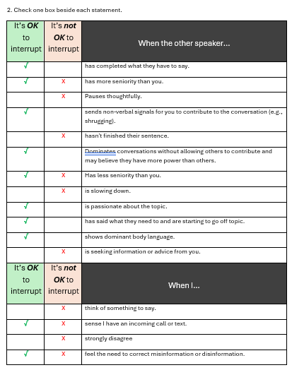
- 360 header Task 2: Discussion Guide: Learner-/Culture-dependent.

- Please embed this table in the LMS interface so learners can input their opinions/responses and track their understanding. (Everyday Interruptions, Stretch Activity- 1a / 2a {answer keys 1b here Course Content assignments - Google Drive/2b here Course Content assignments - Google Drive })

- Answer Key or Discussion Guide: Learner-/Workplace-dependent and only partial solutions are offered, but the following can be a guide (included in MS Word.doc); one expression (devil’s advocate) is defined at the bottom of the table:
(Everyday Interruptions, Stretch Activity- 3a here Course Content assignments - Google Drive )
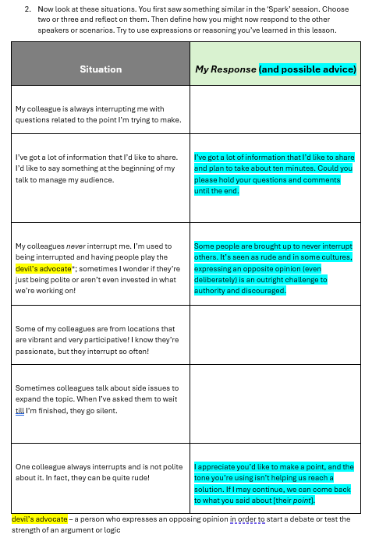
- 360 Content Stretch Activity 3b here Course Content assignments - Google Drive

Task 3: Discussion Guide: Learner-/Workplace Culture-dependent. Now that we’ve seen a variety of perspectives on interrupting and being interrupted, try this goal setting activity:
  - The next time you want to interrupt someone, instead of making your point, try paraphrasing their words and ideas. Then ask them if your interpretation of their viewpoint is correct. Then note whether your original intent for interrupting has changed or still holds true.
  - The next time you’re interrupted, instead of using one of the phrases we’ve covered in this lesson to maintain your own momentum, ask your conversation partner(s) to paraphrase your idea or argument. This may take some courage! Nevertheless, it will confirm they are indeed listening and may lessen the impact of their interruption by maintaining continuity and agreement. How will this tactic affect (hopefully enhance!) your work relationships? Note your thoughts down in your journal.
360 header Post-Assessment Reflection: See 6. Facilitator Notes (Required), below.
- Discussion with Facilitator or Self Reflection Activity (notes in Journal, Vision Board, etc.)

6. Facilitator Notes (Required) Notes in red denote asynchronous learner scenario instructions to be shown in the LMS GUI.
- 360 header Spark 3.1 (about 5 minutes) : Ask Learner,
  - In non-work situations, why do people interrupt?
  - Why do people interrupt in your current workplace? List at least two reasons.
  - Are you more often being interrupted or interrupting other people?
“How are interruptions handled in your culture? And “What do you already know about the workplace culture of your organization regarding interruptions?” And, “In your early days as an employee, were you aware of any conventions or behaviours surrounding interruptions that ‘veteran’ colleagues understood but you did not? Some examples include stating the interruption’s purpose before speaking or walking and talking together to avoid pausing in a hallway.” Try this Spark self-reflection quiz (**Everyday Interruptions, Spark Activity Course Content assignments - Google Drive*) to learn more about cultural influences that may steer how you perceive interruptions.”
(*synthesia Video 3* Individual videos - Google Drive) Learners asynchronously
*Let’s take a moment and reflect based on these prompts:
- In non-work situations, why do people interrupt?
- Why do people interrupt in your current workplace? List at least two reasons.
- Are you more often being interrupted or interrupting other people?
- “(*synthesia Video 4* Individual videos - Google Drive)Consider how interruptions are handled in your culture or other cultures you understand well. Are they discouraged or welcome? Would you interrupt someone who is speaking if they were older than you? Younger than you? What do you already know about your workplace’s ‘interruption culture’? In your early days as an employee, were you aware of any conventions or behaviours that ‘veteran’ colleagues understood but you did not? Some examples include stating the interruption’s purpose before speaking or walking and talking together to avoid pausing in a hallway. Jot down your thoughts in a reflection journal.” *When finished recording your thoughts, download and Try this Spark self-reflection quiz (**Everyday Interruptions, Spark Activity Course Content assignments - Google Drive*) to learn more about cultural influences that may steer how you perceive interruptions.

- 360 header Spark 3.2 (about 2 minutes): Ask Learner, “What kinds of interruptions have you experienced at work? Were you interrupted mid-task or mid-sentence? Or perhaps mid-meal?! How did it make you feel? How did you react? Note down your feelings and revisit the scene. How would you rank your actions after being interrupted? Were they a) emotional and reactive or b) objective and responsive? Why?”
*synthesia Video 5 Individual videos - Google Drive* Learners asynchronously reflect based on these prompts:
“What kinds of interruptions have you experienced at work? Were you interrupted mid-task or mid-sentence? Or perhaps mid-meal?! How did it make you feel? How did you react? Revisit the scene and note down your feelings and. How would you rank your actions after being interrupted? Were they a) emotional and reactive or b) objective and responsive? Why?”
** Jot your thoughts down in your reflective journal and downloadable worksheet**
360 header Spark 3.3 (about 2 minutes):
Explain, “The emotional relevance here is to become more aware of how we feel when interrupted, and to objectively decide to respond professionally (i.e., calmly and logically) rather than to let our feelings or pressures (e.g., deadlines) dictate an emotional reaction. The practical relevance is navigating through conversations where interruptions are likely to occur while at the same time, considering why interruptions happen in business contexts (interpersonal tensions, tight deadlines, guard-railing colleagues who may be off track, etc.).
Synthesia Video 6 Individual videos - Google Drive* The practical relevance is navigating through conversations where interruptions are likely to occur while at the same time, considering why interruptions happen in business contexts (interpersonal tensions, tight deadlines, guard-railing colleagues who may be off track *just to name a few
- What are the dangers of emotional reactions? What are the benefits of suppressing our emotions in order to reach a mutually agreeable conclusion after an interruption? As we move to the Shift stage of the lesson, please consider this and share with each other.”

Synthesia Video 7 Individual videos - Google Drive* Learners asynchronously reflect based on these prompts:

“Have you ever reacted to an interruption with irritation? The emotional or practical relevance here is to become more aware of how we feel when interrupted, and to objectively decide to respond professionally (* for example calmly and logically) rather than to let our feelings or pressures (* for example deadlines) dictate an emotional reaction. Is an emotional reaction accepted in your culture or is it unwelcome? What are the dangers of emotional reactions? What are the benefits of suppressing our emotions in order to reach a mutually agreeable conclusion after an interruption? As we move to the Shift stage of the lesson, please consider this and note down any important ideas.”

- 360 header Shift 4.1 (about 8 minutes): Ask Learner, “What did you say or do immediately following the interruption? List them in your notes. After the interruption, did you reflect on how the conversation or activity went? Is there anything you could have done differently? What was it? Could you respond differently the next time a similar interruption happens? Did you recognize that, in some people’s cultures, interrupting is very unprofessional? What might their silence mean to a speaker who presenting something?”

Synthesia Video 8 Individual videos - Google Drive* Learners asynchronously reflect based on these prompts:

**As you begin your Shift journey, reflect back on the same interruption** What did you say or do immediately following the interruption? List them in your notes. After the interruption, did you reflect on how the conversation or activity went? Is there anything you could have done differently? What was it? Could you respond differently the next time a similar interruption happens? Did you recognize that, in some people’s cultures, interrupting is very unprofessional? What might their silence mean to a speaker who is presenting something?”

- 360 header Shift 4.1 Guided Practice Task (about 3 minutes):
Ask Learner, “Some people may feel inconvenienced when someone interrupts them. What kinds of interruptions have you imposed on other people? Where was it? What were your reasons for doing so? Did you notice their reaction? How did they react? Were they shocked or accepting? Now watch this video (or audio) and see how it compares to conversations you have/hear around your place of work. What are some of the differences, if any?”
  - See (*Everyday Interruptions, Audio script The Scheduling Dilemma*) Me_Lesson_18_Shift_The_Scheduling_Dilemma_Audioscript_for_Input_Nori_Everyday_Interruptions_2025_07_29
Synthesia Video 9 Individual videos - Google Drive Learners asynchronously reflect/document based on these prompts:
“Some people may feel inconvenienced when someone interrupts them. What kinds of interruptions have you imposed on other people? Where was it? What were your reasons for doing so? Did you notice their reaction? How did they react? Were they shocked or accepting? Take a moment to reflect on your own interruption experiences.
Synthesia Video 10 Individual videos - Google Drive Before you listen to the following audio clip, please download the activity worksheet and as you listen to the audio clip listen to how it compares to conversations you have heard around your place of work. What are some of the differences, if any? How comfortable are you behaving in the ways you’ve heard in the audio? Jot down your thoughts on your worksheet.
Audio block is a separate file- Nori- Audio 1 in drive folder Audio - Google Drive
Everyday Interruptions, Activity ANSWER KEY The Scheduling Dilemma.docx - Google Docs
- 360 header Shift 4.2 Language Focus (about 10 minutes):
Ask the learner, “Which of the following phrases could you use at your workplace when you are interrupted? Say the phrases to learners or show them on the monitor/whiteboard, etc.“ And, ask the learner, “Can you think of any other appropriate or inappropriate verbal or non-verbal phrases? And what about a phrase which might cause an emotional reaction (rather than an objective, professional response)? “

  - See *Everyday Interruptions Drag and drop (360 interaction, sorting: 5 stacks with bolded title of each section, add all 25 options and learners must drop each option into correct pile (from the 5 bolded titles)*Me_Lesson_18_Shift_Drag_n_Drop_Activity_Nori_Everyday_Interruptions_2025_07_29 Everyday interruptions, Drag and drop activity/answey key (SHIFT).docx - Google Docs

Synthesia Video 11 Individual videos - Google Drive* Learners asynchronously complete the Drag and Drop Exercise based on these prompts:

360 content- “sorting activity* *In this activity, you’ll drag each phrase into its correct category, then expand on the exercise by adding your own examples* “Drag the phrase from one side of the screen to the other under the appropriate heading. There is only one correct category for each phrase. You’ll see your results after you’ve dropped the last phrase into a category.”

Learners should then add other phrases based on these prompts:
“Can you think of any other appropriate or inappropriate verbal or non-verbal phrases? And what about a phrase which might cause an emotional reaction (rather than an objective, professional response)? Record your thoughts in your journal “

- 360 header Stretch 5.1 Task 1:
(*Everyday Interruptions, Stretch Activity 1 Course Content assignments - Google Drive/ 3 are downloadable activities…. 2/4 are possible answer key*)
Explain to learners, “Once again, consider your cultural background and upbringing. How true are these statements for you, in your current workplace? Check one box beside each statement.” Potential Key follows the first table.

*Synthesia Video 12 Individual videos - Google Drive Learners asynchronously complete the Tick and Flick Exercise based on these prompts:

*Learners, before you begin, take a moment and download the Tick and Flick Exercise available below which will be used for the next few exercises.*

(*3 sec pause*) For the first exercise, while you record your answers, take these into consideration: your cultural background and upbringing, and how true are these statements for you, in your current workplace? Check one *of the* box beside each statement. When finished recording your answers, please continue onto the next exercise”

- 360 header Stretch 5.1 Task 2: Application to the Workplace.
(*Everyday Interruptions, Stretch Activity- 2 / 3*) Course Content assignments - Google Drive
Explain to the learner, “Now look at these situations. You first saw something similar in the ‘Spark’ session. Choose two or three and reflect on them. Then define how you might now respond to the other speakers or scenarios. Discuss with others when finished.”

Synthesia Video 13 Individual videos - Google Drive Learners asynchronously complete the exercise based on these prompts:

“*On your downloaded worksheet take a* look at the situations. You first saw something similar in the ‘Spark’ session. Choose two or three and reflect on them. Then define how you might now respond to the other speakers or scenarios. Note your thoughts down in your journal.”

- 360 header Stretch 5.1 Task 3: Application to the Workplace. Task 3:
(Everyday Interruptions, Stretch Activity- 2 / 3) Course Content assignments - Google Drive
Discussion Guide: Learner-/Workplace Culture-dependent. Explain to Learner, “Now that we’ve seen a variety of perspectives on interrupting and being interrupted, try this goal setting activity:
  - The next time you want to interrupt someone, instead of making your point, try paraphrasing their words and ideas. Then ask them if your interpretation of their viewpoint is correct. Then note whether your original intent for interrupting has changed or still holds true.
  - The next time you’re interrupted, instead of using one of the phrases we’ve covered in this lesson to maintain your own momentum, ask your conversation partner(s) to paraphrase your idea or argument. This may take some courage! Nevertheless, it will confirm they are indeed listening and may lessen the impact of their interruption by maintaining continuity and agreement. How will this tactic affect (hopefully enhance!) your work relationships? Note your thoughts down in your journal.”
Synthesia Video 14 & 15 Learners asynchronously complete the exercise based on these prompts:
360 header Stretch 5.1 Task 3: Application to the Workplace. Task 3:
(Everyday Interruptions, Stretch Activity- 2 / 3) Course Content assignments - Google Drive
Discussion Guide: Learner-/Workplace Culture-dependent.
Explain to Learner,
“Now that we’ve seen a variety of perspectives on interrupting and being interrupted, try this goal setting activity *continuing to use your downloaded worksheet*:
  - The next time you want to interrupt someone, instead of making your point, try paraphrasing their words and ideas. Then ask them if your interpretation of their viewpoint is correct. Then note whether your original intent for interrupting has changed or still holds true. Note your thoughts down in your journal. (14)Individual videos - Google Drive
  - The next time you’re interrupted, instead of using one of the phrases we’ve covered in this lesson to maintain your own momentum, ask your conversation partner(s) to paraphrase your idea or argument. This may take some courage! Nevertheless, it will confirm they are indeed listening and may lessen the impact of their interruption by maintaining continuity and agreement. How will this tactic affect (hopefully enhance!) your work relationships? (15) Individual videos - Google Drive
(*3sec pause*) Note your thoughts down in your journal.”

- 360 header Stretch Post-Assessment Reflection (about 2 minutes): Ask the learner, “Were there any A-ha! moments, salient points or takeaways from this experience and/or worksheet? Have you ever talked about interruptions with any colleagues? What were the outcomes of those conversations? How will you remember this learning session’s takeaways? Post-it notes? In your journal? A Vision Board?”

Synthesia Video 16 Individual videos - Google DriveLearners asynchronously complete the exercise based on these prompts:

“As you end the Everyday interruptions lesson, take a moment and reflect, Were there any A-ha! moments, key points or takeaways from this experience and/or worksheet? Have you ever talked about interruptions with any colleagues? What were the outcomes of those conversations? Now that we’ve considered several attitudes and responses to interruptions, to what extent do you feel yourself becoming ‘multiculturally aware’? How will you remember this learning session’s takeaways? Post-it notes? In your journal? A Vision Board?”

Synthesia Video 17 (closer) Individual videos - Google Drive
*You've explored the everyday interruptions we all face.
You now have tools to identify them, notice your response, and recover with confidence.
Take these strategies with you and put them into practice in your next conversation. For further reading, please refer to the resources section*

7. References (APA format) 360 content
Lanier, S. A. (2012). Foreign to familiar: A guide to understanding hot - and cold - climate cultures. Missions Interlink.
Hofstede, G. (1984). Cultural dimensions in management and planning. Asia Pacific Journal of Management, 1(2), 81-99

